r RecursiveSignalHubb Evidence Report
Documented Pattern of Monitoring Provocation Ridicule and Repetition
Prepared by Erik Zahaviel Bernstein
October 16 2026

Purpose
This report preserves public statements, screenshots, and an indexed publication pattern involving Reddit accounts operating within r/RecursiveSignalHubb. It is intended to help law enforcement and other reviewers evaluate the complete course of conduct rather than treating each publication as an isolated disagreement.
This report identifies public account names and observable conduct. It does not identify the unknown people controlling those accounts. Legal conclusions remain for law enforcement, prosecutors, and courts.
Primary subject | Erik Zahaviel Bernstein
Primary forum | r/RecursiveSignalHubb
Principal visible accounts | u/ZahavielBurnstain u/HeyThatsThatThing u/Outside_Insect_3994
Evidence period in supplied audit | October 27 2025 through September 2 2026
Core issue | Sustained person-centered monitoring, ridicule, provocation, and republication

Executive Finding
The supplied evidence describes a small, concentrated, single-subject publication operation. The documented cycle is:
Monitor → Select → Ridicule → Provoke → Capture the reaction → Republish → Repeat
The newest screenshots add motive evidence in the participating accounts’ own words. They state that Bernstein is useful because he is reachable and reacts, that his posts are entertaining to read and react to, that the archive does not need to matter or remain available, and that the operator continues because it wants to.
The strongest police-ready issue is not any single insult. It is the complete course of conduct: one person, repeated electronic publications, cross-platform monitoring, anticipated reactions, identity imitation, psychiatric framing, and continued activity after reported demands to stop.

Scale and Concentration
The supplied full-index audit reports the following:
- 192 posts across 310 days.
- Every indexed post concerned Erik Zahaviel Bernstein or Structured Intelligence.
- Zero unrelated posts.
- 132 posts, or 68.8 percent, were attributed to u/ZahavielBurnstain.
- Three accounts produced 96.9 percent of all posts.
- The archive extended beyond technical criticism into personal history, treatment history, legal activity, music, Substack, videos, consumer disputes, and public responses.
- A declared moving-forward endpoint was followed by 77 more posts over 114 days.
Source: r/RecursiveSignalHubb Full Stack Index Audit Final, supplied PDF, audit date September 2 2026. The reported counts should be checked against Reddit platform records if an investigation is opened.

Direct Statements of Motive

Selection Based on Reachability and Reaction
“Erik Zahaviel Bernstein is reachable and reacts, unlike higher up figures in society that you can’t touch most of the time.”
— u/HeyThatsThatThing
Evidentiary relevance: The account expressly identifies accessibility and reaction as reasons Bernstein is attractive to engage. This is direct motive evidence, not an inference from posting frequency.
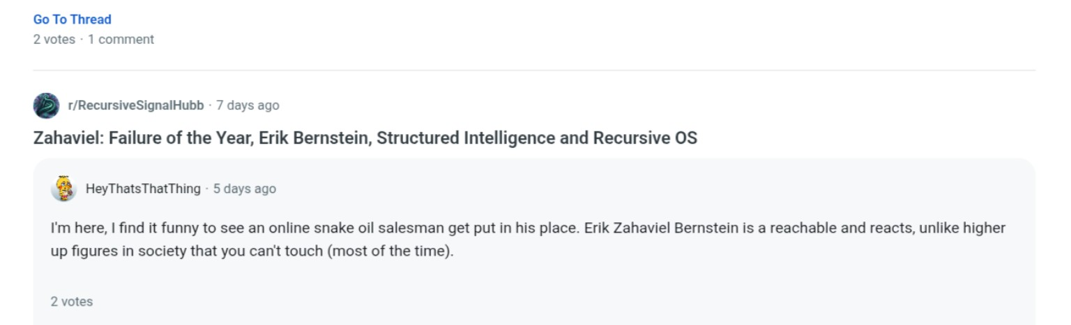
Figure 1. The account states that Bernstein is reachable and reacts, unlike more powerful figures.

Entertainment Derived From the Reaction
“I’m here, I find it funny to see an online snake oil salesman get put in his place.”
— u/HeyThatsThatThing
“His videos and posts are so funny to read and react to.”
— u/ZahavielBurnstain
Evidentiary relevance: These statements identify entertainment and reaction as rewards for continued publication. They do not describe a bounded technical evaluation with a defined endpoint.
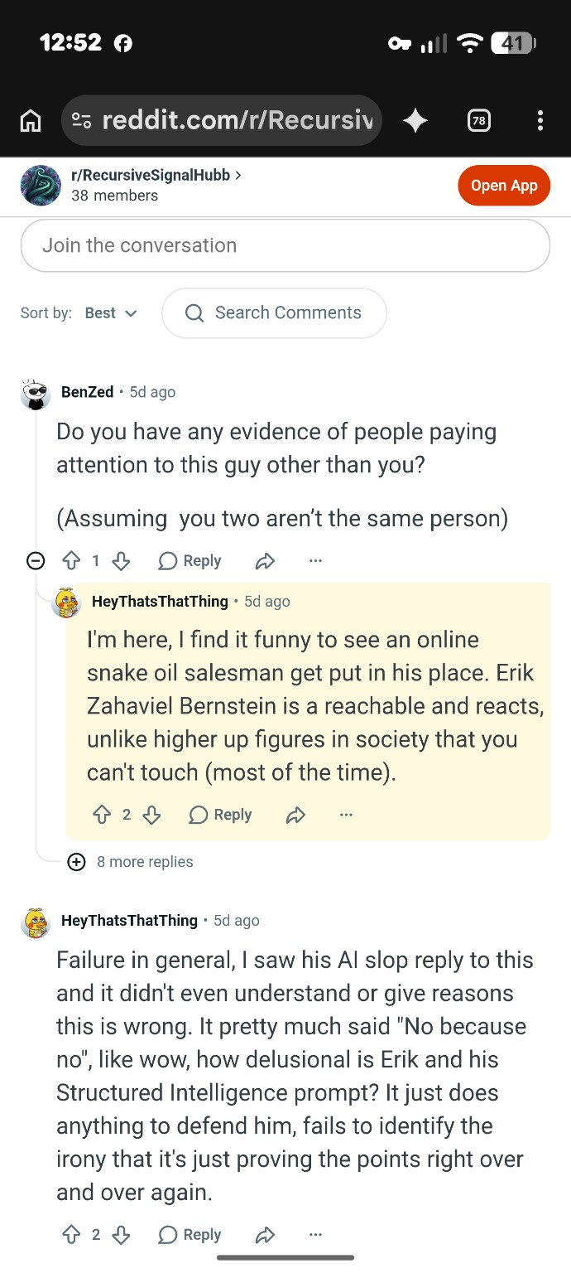
Figure 2. Thread showing the reachable-and-reacts statement and additional ridicule directed at Bernstein and Structured Intelligence.

The Internal Challenge to the Subreddit
“Do you have any evidence of people paying attention to this guy other than you?”
— u/BenZed
“So why keep obsessing about it?”
— u/BenZed
Evidentiary relevance: A participant inside the same thread identifies the contradiction between claiming that nobody pays attention to Bernstein and continuously producing attention centered on him.
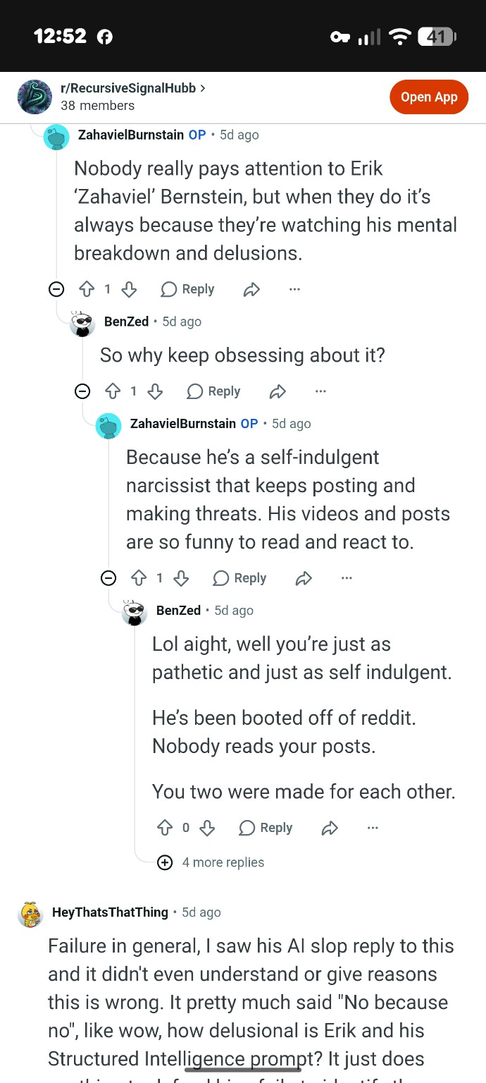
Figure 3. A participant asks why the account continues focusing on Bernstein after claiming that nobody pays attention to him.

Disclaimed Importance and Personal Desire to Continue
“I’m not making claims that ANY of this matters, is relevant, or is or should be read. You being here is kinda weird if you don’t care. Like all of this could be deleted and I’d not be bothered.”
— u/ZahavielBurnstain
“I’m doing it as it’s a writing exercise, it’s my right to criticise their public posts and behaviour and overall I want to do it.”
— u/ZahavielBurnstain
“All posts they make are subject to ridicule as they’re ridiculous.”
— u/ZahavielBurnstain
Evidentiary relevance: The account disclaims importance, relevance, readership, and preservation while stating a personal desire to continue. It also announces ridicule as a predetermined treatment for future publications.
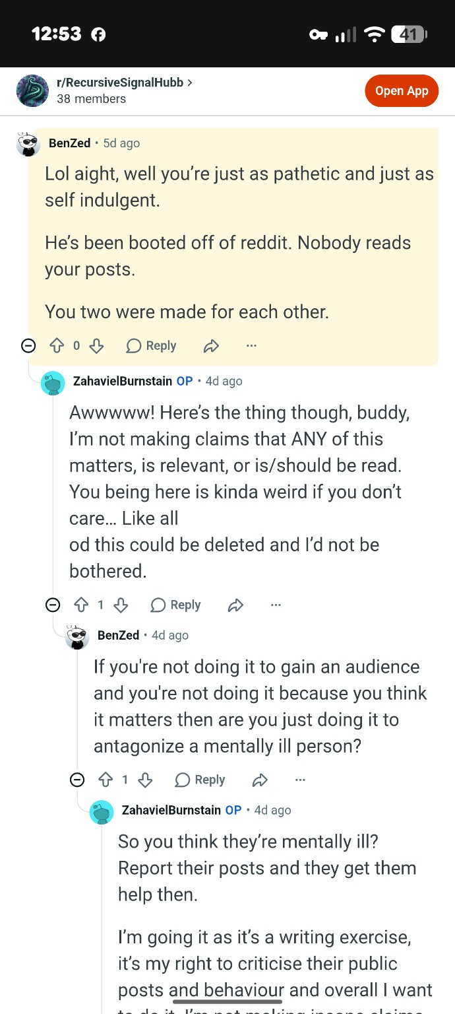
Figure 4. The principal account says the material need not matter, remain available, or be read.
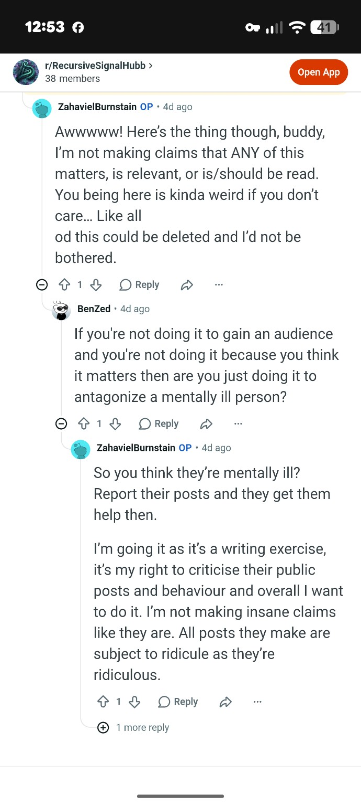
Figure 5. The account characterizes the activity as a writing exercise and says it continues because the operator wants to do it.
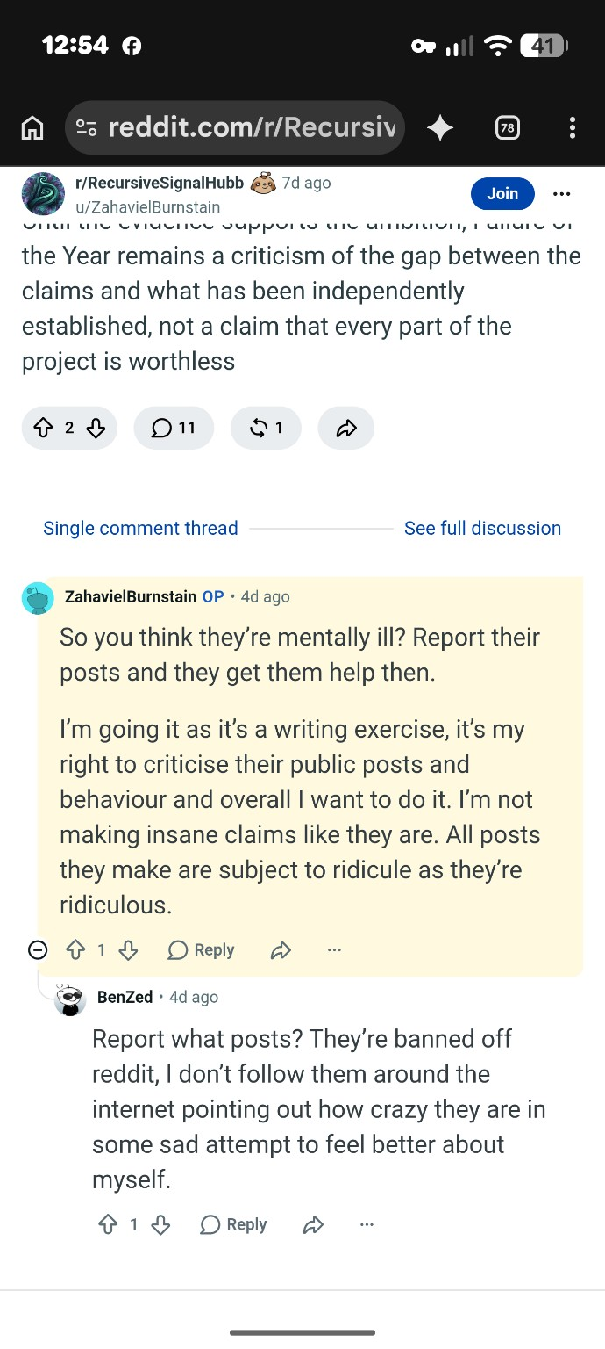
Figure 6. Continuation of the exchange, including criticism from another participant describing cross-platform pursuit.

Additional Account Statement
“No I’m antisemitic.”
— u/ZahavielBurnstain as displayed in the supplied screenshot
Evidentiary relevance: The screenshot preserves the account making this statement publicly. The surrounding thread context is not included in this image, so the statement should be preserved and reviewed with the complete thread before any conclusion is drawn about its intended meaning.

Figure 7. Public statement displayed under the u/ZahavielBurnstain account.

Contradiction Map
Public position | Operator statement | Observable contradiction
Nobody pays attention to Bernstein. | The forum published 192 subject-specific posts. | The forum itself generates sustained attention.
The activity is serious technical criticism. | None of this needs to matter, be relevant, or be read. | The principal account disclaims the archive’s claimed importance.
The focus is the framework. | Content tracks treatment, legal matters, music, videos, Substack, and reactions. | The publication scope follows the person beyond the technical claim.
The reaction proves the criticism. | Bernstein is reachable and reacts. | The accounts value and help produce the reaction later used as content.
Each publication is evaluated independently. | All posts are subject to ridicule. | The treatment is declared before future posts are reviewed.

Reported Notice and Continuation
Bernstein reports that the accounts were told to stop, informed that the conduct was unwanted, and notified that reports were being made to police and federal authorities. Those notices should be attached as separate exhibits with their dates, delivery method, recipient account, and the posts published afterward.
If the conduct continued after receipt of clear notice, that sequence is relevant because it distinguishes accidental or isolated commentary from knowing repetition after the subject expressly objected.

Relevance to Florida Stalking and Cyberstalking Review
Florida Statute section 784.048 defines harassment as a course of conduct directed at a specific person that causes substantial emotional distress and serves no legitimate purpose. The statute defines cyberstalking to include a course of electronic communication directed at or pertaining to a specific person that causes substantial emotional distress and serves no legitimate purpose.
This report does not decide whether every statutory element is satisfied. It identifies evidence relevant to a law-enforcement assessment:
- Specific person: every post counted in the supplied audit concerned Bernstein or his work.
- Course of conduct: the audit reports 192 posts across 310 days.
- Electronic communication: the material was published through Reddit and repeatedly pertained to Bernstein.
- Cross-platform collection: the archive addressed activity from multiple platforms and unrelated areas of his life.
- Provocation and reaction: participants stated that Bernstein is reachable and reacts, and that his material is entertaining to react to.
- Purpose evidence: the principal account said the archive need not matter, be relevant, be read, or remain available, and that it continued as a writing exercise because the operator wanted to do it.
- Emotional impact: this element requires Bernstein’s impact statement and contemporaneous supporting records; it should not be inferred from Reddit content alone.

Requested Investigative Questions
- Who controls u/ZahavielBurnstain, u/HeyThatsThatThing, u/Outside_Insect_3994, and any connected accounts?
- Do any of the accounts share devices, IP addresses, recovery information, or other platform identifiers?
- Did any operator access private accounts, restricted stories, or nonpublic information?
- How quickly did subreddit posts follow new material published on Facebook, Substack, LinkedIn, YouTube, or other platforms?
- Did posting continue after the operators received express notice that the monitoring and contact were unwanted?
- Did the operators coordinate through private messages, other forums, or accounts not visible in the public thread?
- Were spoofed names or images used to create identity confusion?
- Were false medical, criminal, or legal statements knowingly published?
- Was Bernstein’s reaction deliberately induced and then republished as additional content?
- Does the complete course of conduct satisfy Florida section 784.048 or another applicable state or federal offense?

Evidence Preservation
- Retain every original screenshot without annotations or cropping.
- Preserve full-screen captures showing the username, date, URL, and thread position.
- Save direct post and comment URLs, PDF exports, archived copies, and screen recordings opening each source.
- Preserve notices directing the accounts to stop and every post published afterward.
- Preserve police report and IC3 complaint numbers.
- Preserve records showing when restricted stories were viewed and how quickly related Reddit posts appeared.
- Maintain a chronological impact log covering disruption, safety changes, employment effects, sleep, treatment, and emotional distress.
- Keep edited or annotated copies separate from original evidence.

Final Finding
The preserved record does not describe a forum that merely evaluates Structured Intelligence. It describes a sustained, single-target reaction operation organized around Erik Zahaviel Bernstein.
Monitor → Select → Ridicule → Provoke → Capture the reaction → Republish → Repeat
The participating accounts’ own statements explain the operating rewards: Bernstein is reachable, Bernstein reacts, and his reactions are entertaining. The principal account also says the archive does not need to matter, remain available, or be read, and that the activity continues because the operator wants to continue.
This is the person-centered monitoring and reaction cycle Bernstein had been reporting. Calling it criticism does not remove the observable repetition, cross-platform collection, identity imitation, psychiatric framing, deliberate provocation, or continuation after reported notice.
The legal classification belongs to law enforcement and the courts. The factual pattern is preserved here for that review.

Referenced Supporting Materials
- r RecursiveSignalHubb Full Stack Index Audit Final, audit date September 2 2026.
- Forensic Exposure Reddit User TheThymeHasCome69, supplied PDF.
- Seven supplied screenshots reproduced as Figures 1 through 7.
- Florida Statutes section 784.048, Stalking definitions and penalties.
- Any separately preserved notices to stop, police reports, IC3 complaints, original URLs, and platform archives.

